# Write and upload the first program using Arduino

Difficult Level: 

## A. Download Arduino IDE

Open <https://www.arduino.cc/en/software>. Download the appropriate package for your operating system.

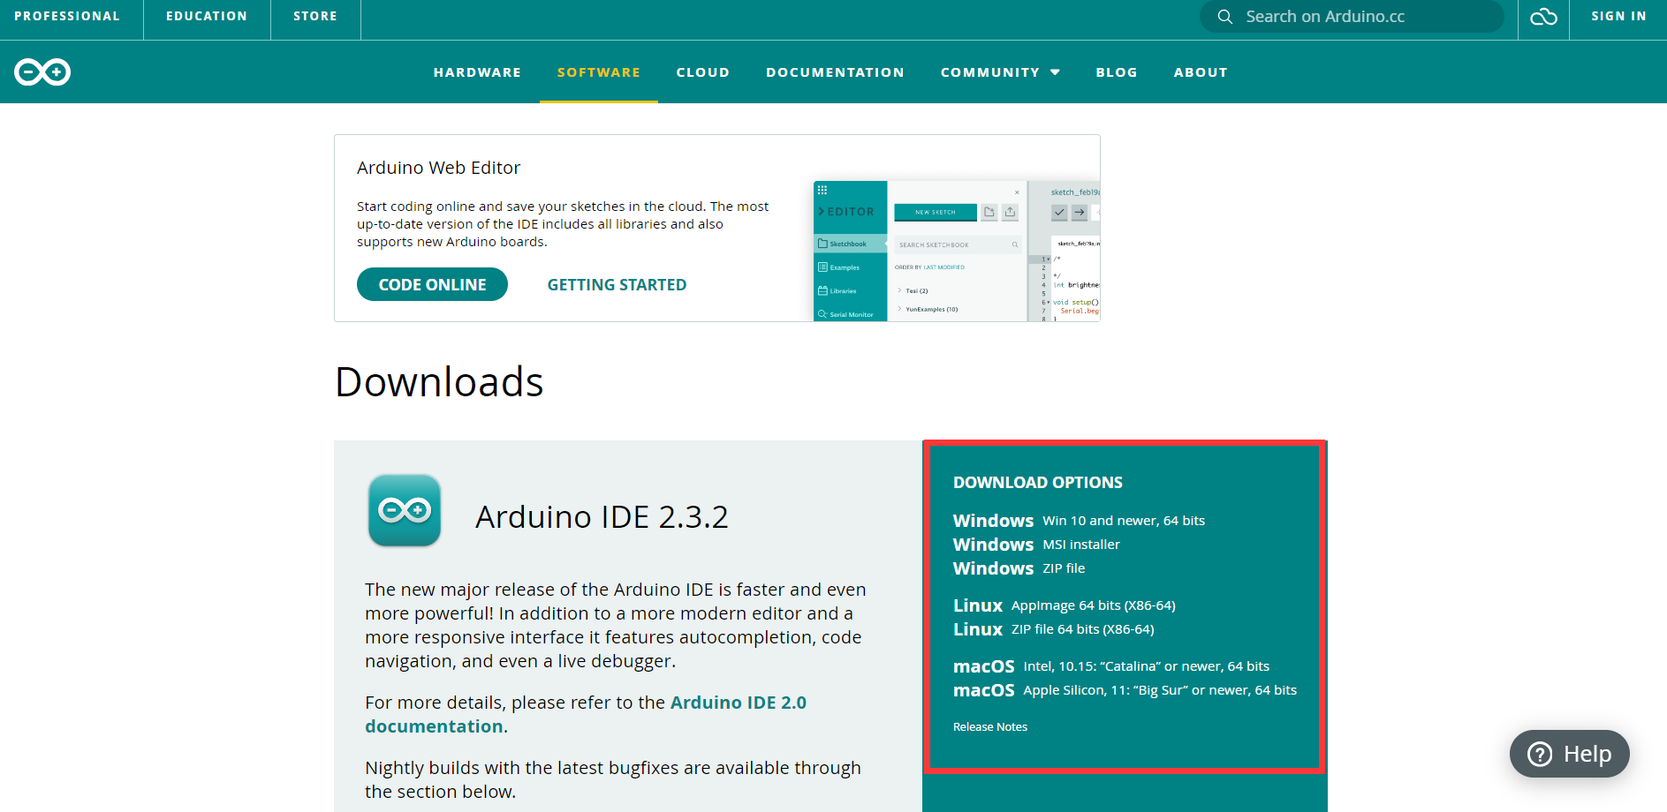

Click it.

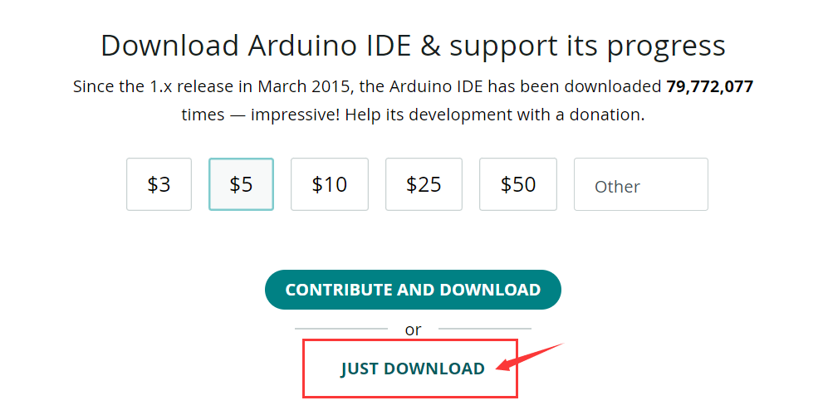





Then start download it. After finish it, you will get this:



Double click to run this exe file for installation.

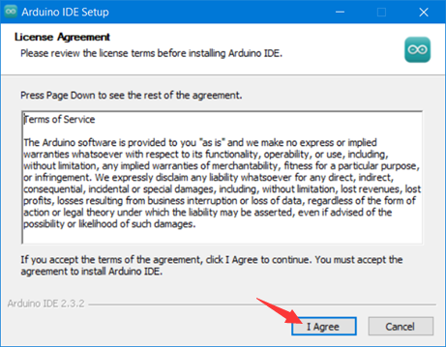

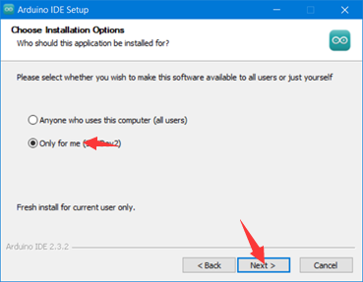

Then you can choose a path to install the Arduino IDE folder.

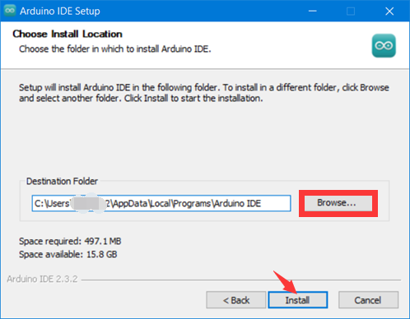

Last click the finish button to run Arduino IDE.

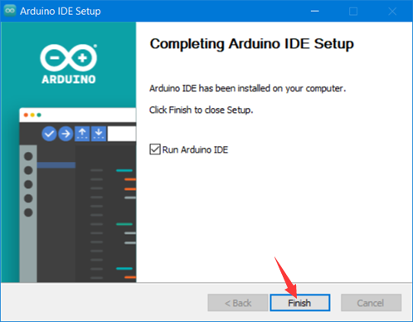

## B. Get to know everything in the KIT

### Arduino UNO R4 WIFI

The Arduino UNO R4 Wi-Fi is designed around the 32-bit microcontroller RA4M1 from Renesas while also featuring an ESP32 module for Wi-Fi® and Bluetooth® connectivity. Its distinctive 12x8 LED matrix makes it possible to prototype visuals directly on the board, and with a Qwiic connector, you can create projects plug-and-play style.

The MCU on the board is the high performance Renesas RA4M1 (Arm® Cortex®-M4) with a 48 MHz clock speed, 32 kB SRAM and 256 kB flash memory. This MCU features an RTC, a DAC and a CAN bus and has support for HID via USB.

The UNO R4 Wi-Fi also features an ESP32-S3 for Wi-Fi®/Bluetooth® connectivity, which can also be separately programmed via a specific header.

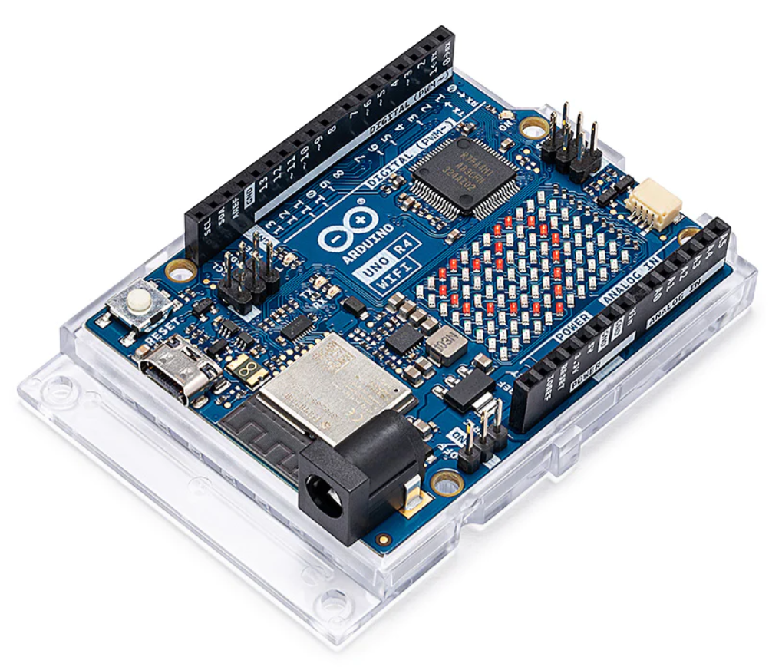

### Temperature & Humidity Sensor

This is a basic, digital temperature and humidity sensor. It uses a capacitive humidity sensor and a thermistor to measure the surrounding air and spits out a digital signal on the data pin (no analog input pins needed). It's fairly simple to use but requires careful timing to grab data. This sensor can be easily interfaced with any microcontroller to measure humidity and temperature instantaneously.

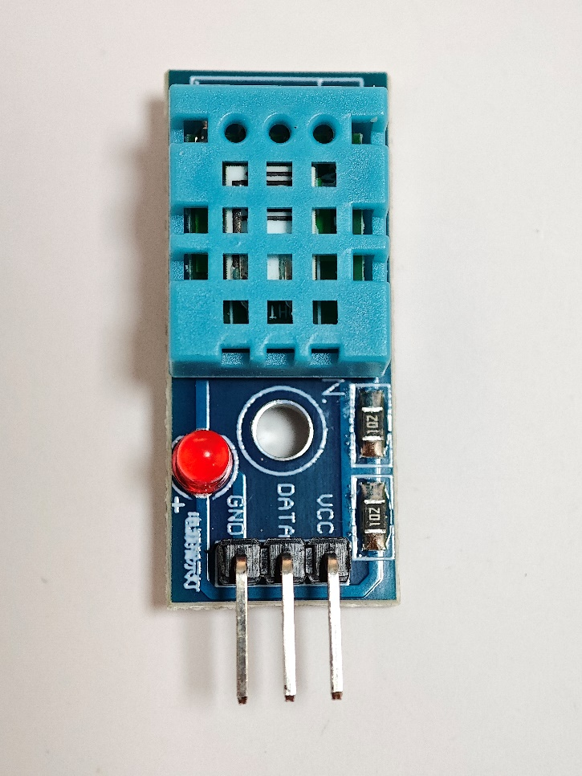

Only three pins are available for use: VCC, GND, and DATA. The communication process begins with the DATA line sending start signals to, and Temperature and humidity sensor receives the signals and returns an answer signal. Then the host receives the answer signal and begins to receive 40-bit humidity and temperature data (8-bit humidity integer + 8-bit humidity decimal + 8-bit temperature integer + 8-bit temperature decimal + 8-bit checksum).

#### Pinout

* GND/- -Connect to Ground
* VCC/+ -Connect to 3.3V/5V power supply
* DATA -Data output

### BMP280 Air Pressure meter

The BMP280 is an absolute barometric pressure sensor, which is especially feasible for mobile applications. Its small dimensions and its low power consumption allow for the implementation in battery powered devices such as mobile phones, GPS modules or watches. The BMP280 is based on Bosch’s proven piezo resistive pressure sensor technology featuring high accuracy and linearity as well as long-term stability and high EMC robustness. Numerous device operation options guarantee for highest flexibility. The device is optimized in terms of power consumption, resolution and filter performance.

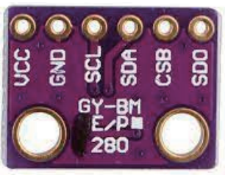

#### Pinout

* VCC-3.3v Power supply.
* GND-connect to Ground.
* SCL-connect to I2C’s clock pin.
* SDA-connect to I2C’s data pin.
* CSB-Do not connect unless you want to use SPI protocol, it connects to SPI’s chip select pin.
* SDO-This is the Serial Data Out / Microcontroller in Sensor Out pin, for data sent from the BMP280 to your processor.

### 9g servo

A servo motor is an electromechanical device that produces torque and velocity based on the supplied current and voltage. A servo motor works as part of a closed loop system providing torque and velocity as commanded from a servo controller utilizing a feedback device to close the loop. You can build your own mechanical device such as robot, smart car turning wheel or something else.

Servo motor is a component that can rotate its handle (usually between 0 and 180 degrees). It used to control the angular position of the object.

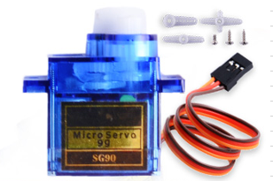

#### Pinout

* VCC pin: (typically red) needs to be connected to VCC (5V).
* GND pin: (typically black or brown) needs to be connected to GND (0V).
* Signal pin: (typically yellow or orange) receives the PWM control signal from an Arduino’s pin.

### Ultrasonic sensor

The Ultrasonic Module (HC-SR04) is a sensor that can measure distances between 2cm and 400cm using ultrasonic waves. It is commonly used in robotics and automation projects to detect objects and measure distances. The module consists of an ultrasonic transmitter and receiver, which work together to send and receive ultrasonic waves.

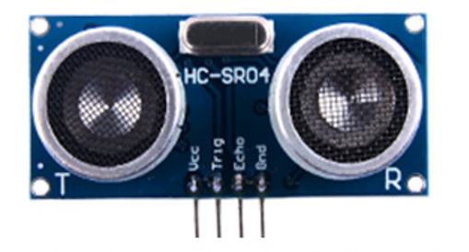

#### Pinout

* VCC: You can connect it to the 5V output from your Arduino.
* Trig (Trigger): is used to trigger ultrasonic sound pulses.
* Echo:  Echo pin is an Output pin. This pin goes high for a period of time which will be equal to the time taken for the US wave to return back to the sensor.
* GND: Connect it to the ground of the Arduino.

### MPU6050 Gyroscope & accelerate

The MPU-6050 is a 6-axis (combines 3-axis Gyroscope, 3-axis Accelerometer) motion tracking devices. Changes in motion, acceleration and rotation can be detected. It is commonly used in robotics, gaming controllers, and other electronic devices that require motion detection. Its high accuracy and cheap cost make it very popular among the DIY community.

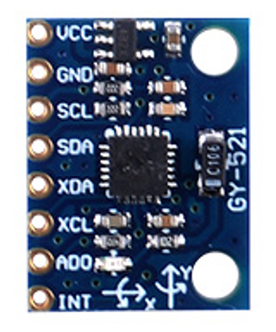

#### Pinout

* VCC: supplies power to the module.
* GND: is the ground pin.
* SCL:  is a serial clock pin for the I2C interface.
* SDA:  is a serial data pin for the I2C interface.
* XDA:  is the external I2C data line. The external I2C bus is for connecting external sensors, such as a magnetometer.
* XCL:  is the external I2C clock line.
* AD0:  If more than one MPU6050 is used a single MCU, then this pin can be used to vary the address.
* INT:  is the Interrupt Output pin. Interrupt pin to indicate that data is available for MCU to read.

### 2 channel relay

The dual-channel relay module contains switching relays and the associated drive circuitry to make it easy to integrate relays into a project powered by a microcontroller. On the left are two terminal blocks, which are used to connect mains wires to the module without soldering.

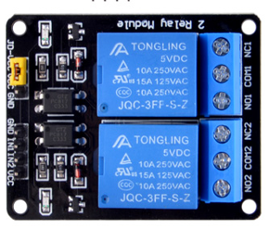

There are several differences when compared to the single-channel relay module. The first is that the optocoupler and relay can have a separate power supply from the input. This is selected using the JD-VCC jumper – if the jumper is shorted, then the relay coil and optocoupler output are connected to the signal VCC. If the jumper is left open, a separate power supply can be provided to the relay coil through the JD-VCC pin.

The second is that the input is active low, meaning that the relay coil is activated only when the input is low. This is because the optocoupler input and the indicator LED are chained to VCC. When the input is high, the voltage difference across the chain is 0V and no current can flow, but when the input is low, supply voltage appears across the chain and the optocoupler output conducts, supplying current to the base of the drive transistor, turning the relay on.

#### Pinout

* JD-VCC: Input for isolated power supply for relay coils.
* VCC: Input for directly powering the relay coils.
* GND: Input ground reference.
* GND: Input ground reference.
* IN1: Input to activate the first relay.
* IN2: Input to activate the second relay.
* VCC: VCC to power the optocoupler, coil drivers, and associated circuitry.

### 52Pi experiment platform

An experiment platform.

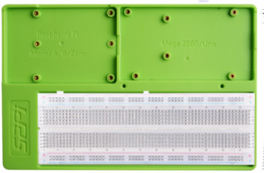

### USB-C Programing Cable

A USB-C Programing Cable.

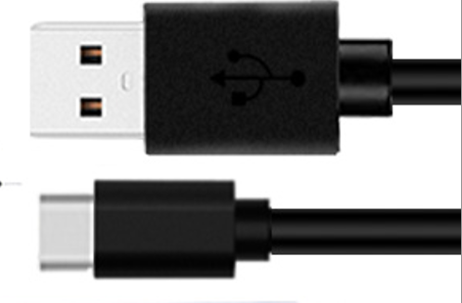

### TF card Reader Module

TF cards are widely used in various applications, such as data logging, data visualization, and many more. TF Card Reader modules make it easier for us to access these TF cards with ease. The TF Card Reader module is an easy-to-use module with an SPI interface and an on-board 3.3V voltage regulator to provide proper supply to the TF card.

#### Pinout

* VCC pin provides power to the module and should be connected to the Arduino’s 5V pin.
* GND is a ground pin.
* MISO (Master in Slave OUT) is the SPI output.
* MOSI (Master out Slave IN) is the SPI input.
* CLK (Serial Clock) pin accepts clock pulses from the master (an Arduino in our case) to synchronize data transmission.
* CS (Chip Select) pin is a control pin that is used to select one (or a set) of slave devices on the SPI bus.

### A 32GB TF Card

1 x 32GB TF Card.

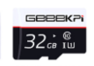

### USB Card Reader

1 x USB Card Reader.

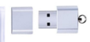

### LCD1602

An I2C LCD1602 is a device that can display text and characters on a 16x2 (16 columns and 2 rows) liquid crystal display (LCD) using the I2C protocol. You can use an I2C LCD1602 to show information from your Arduino projects, such as sensor readings, messages, menus, etc. The I2C module has a built-in PCF8574 I2C chip that converts I2C serial data to parallel data for the LCD display.

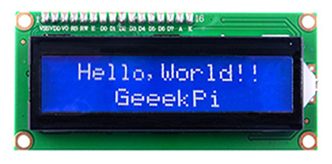

#### Pinout

* GND -Connect to Ground
* VCC -Connect to 3.3V/5V power supply
* SDA -I2C data signal
* SCL -I2C clock signal

Backlight can be enabled by jumper cap, unplug the jumper cap to disable the backlight. The blue potentiometer on the back is used to adjust the contrast (the ratio of brightness between the brightest white and the darkest black).

* Shorting Cap: Backlight can be enabled by this cap，unplug this cap to disable the backlight.
* Potentiometer: It is used to adjust the contrast (the clarity of the displayed text), which is increased in the clockwise direction and decreased in the counterclockwise direction.

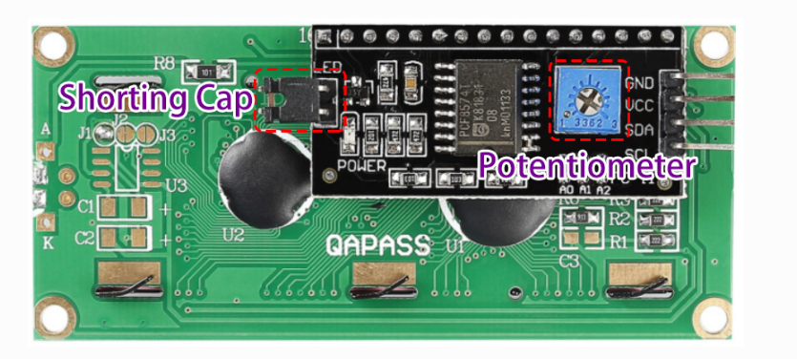

### Long breadboard

1 x Long breadboard.

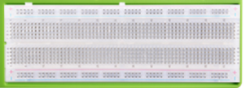

### Jumper wire box

1 x Jumper wire box. Contains a lot of jumpers。

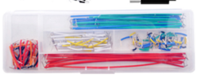

### Male-to-male breadboard Jumper wire

20 x Male-to-male breadboard Jumper wire.

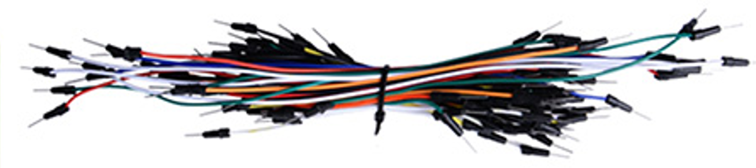

### Female-to-male Jumper wire

40 x Female-to-male Jumper wire.

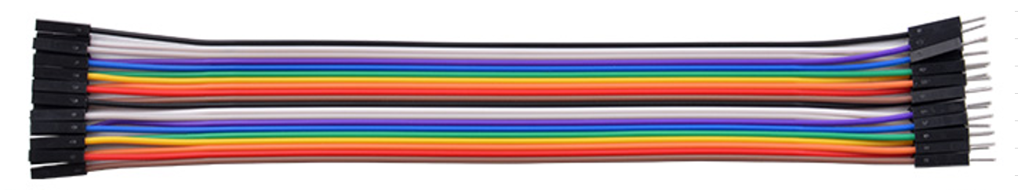

### Male-to-male Jumper wire

20 x Male-to-male Jumper wire.

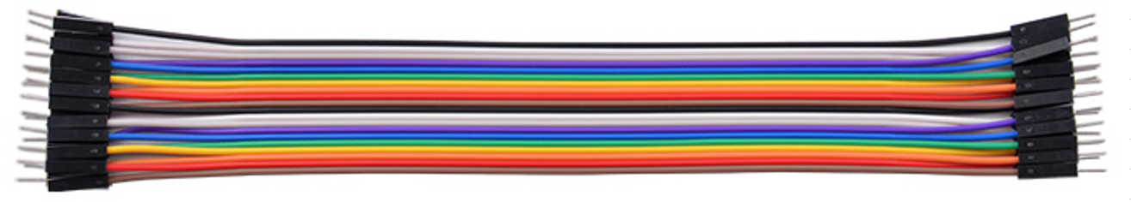

### 3Ω Speaker module

The purpose of speaker is to produce audio output that can be heard by the listeners. Speakers are the transducers that used to convert the electromagnetic waves into sound waves. It receives audio input from computer or audio receivers. The input fed to speaker is in analog or digital form. Analog speakers simply amplify electromagnetic waves into sound waves while digital first convert the signal into analog and then amplify it.

Sound produced by the speaker is defined by frequency and amplitude, where frequency determines how high or low the pitch of the sound is. Amplitude or loudness of the speaker is defines by the change in the air pressure created by the speaker’s sound waves.

We all know that, speakers have few different parameters like impedance, power handling, size, frequency response. Here, impedance tells you that how much current will flow through a speaker at a certain voltage. Like this speaker has 3 ohms of impedance and comes with a power handling capacity of 1W.

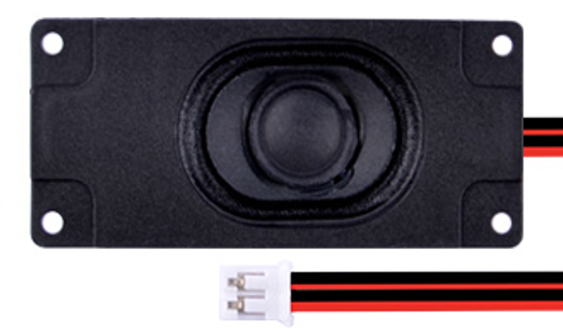

#### Pinout

* GND (The black)
* VCC (The Red)

### Speaker Amplifier (XY-SP5W)

The power supply voltage is 2.5-5.5V, more than 5.5V, the chip will burn out. The power supply current recommended 1A or more, less than 1A sound will be small. The positive and negative poles of the power supply cannot be reversed, and the reverse chip is burnt. The load recommended 4 Euro 3W speakers. This module has a mute switch, high level mute, low level playback, the default is low level playback. This module is suitable for amplifying the audio signal of 0.5V-1V. If the signal is too small, it needs to be connected to the preamplifier. This module is only suitable for single-supply operation and cannot be connected to a negative power supply.

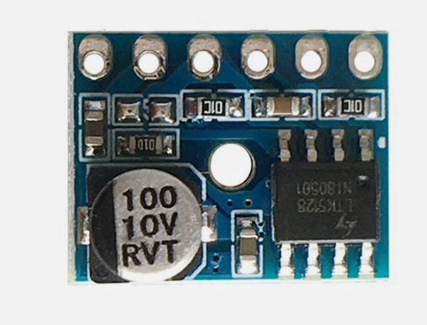

#### Pinout

* Audio output+
* Audio output-
* MUTE
* AGNO
* Audio input
* Power +5V

### LED indicator pack

20 x LED (Five red, yellow, blue and white).

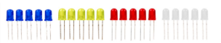

### Press button

6 x Press button.

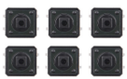

### Button cap

6 x Button cap.

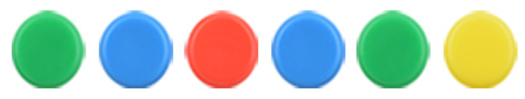

### Buzzer

A buzzer or beeper is an audio signaling device, which may be mechanical, electromechanical, or piezoelectric (piezo for short). Typical uses of buzzers and beepers include alarm devices, timers, train and confirmation of user input such as a mouse click or keystroke.



### Battery cap

A 9V battery cap.

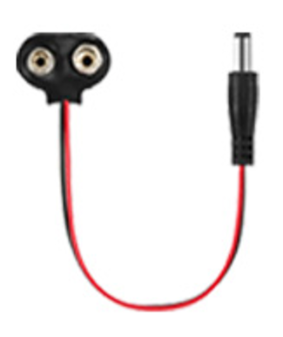

### Sound sensor

The sound sensor, as the name says, detects sound. Detects sound from silence and outputs digital trigger signal. The digital signal can have an adjustable trigger level. LEDs indicate power and output signal. Given that this device measures whether or not sound has exceeded a threshold, you're basically left with determining what it is you want to do.

The sound [sensor is one type of module](https://www.elprocus.com/map-sensor-working-and-its-applications/) used to notice the sound. Generally, this module is used to detect the intensity of sound. The applications of this module mainly include switch, security, as well as [monitoring](https://www.elprocus.com/wireless-monitoring-hardware-for-insightcm-by-national-instruments/). The accuracy of this sensor can be changed for the ease of usage.

This sensor employs a microphone to provide input to buffer, peak detector and an amplifier. This sensor notices a sound, & processes an o/p voltage signal to a microcontroller. After that, it executes required processing.

This sensor is capable to determine noise levels within DB’s or decibels at 3 kHz 6 kHz frequencies approximately wherever the human ear is sensitive. The working principle of a sound sensor is based on the conversion of sound waves into an electrical signal. When sound waves strike a microphone, for example, they cause the diaphragm to vibrate. This vibration generates an electrical signal that is proportional to the amplitude of the sound waves.

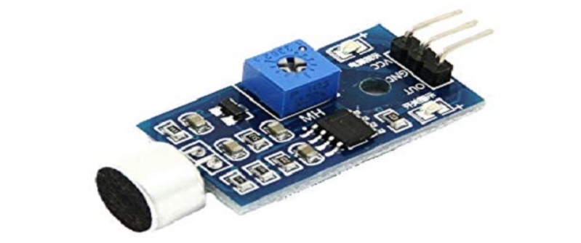

#### Pinout

* VCC -Connect to 3.3V/5V power supply
* GND -Connect to Ground
* OUT -Data output

### Capacitive touch module

The touch switch sensor (also called touch button or touch switch) is widely used to control devices (e.g. touchable lamp). It has the same functionality as a button. It is used instead of the button on many new devices because it makes the product look neat.

This module is a capacitive touch switch module based on a touch sensor IC (TTP223B). In the normal state, the module outputs a low level with low power consumption; when a finger touches the corresponding position, the module outputs a high level and becomes low level again after the finger is released.

Here is how the capacitive touch switch works:

A capacitive touch switch has different layers—top insulating face plate followed by touch plate, another insulating layer and then ground plate.

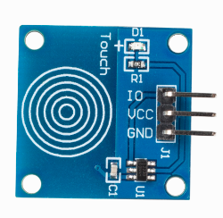

#### Pinout

* VCC -Connect to 3.3V/5V power supply
* GND -Connect to Ground
* IO -IO Data

### CAN BUS Module

High-speed CAN transceivers with up to 8 Mbit/s transmission speed for automotive and many other applications.

Initially, the CAN technology was invented to offer robust and scalable networks in the car. With faster data rates it turned out to be more difficult to keep this robustness. Developing complex networks with low data rates e.g., 500 Kbit/s or 1 Mbit/s had been comparably easy. Faster networks using 2 Mbit/s or 5 Mbit/s data rate could be only realized in smaller and less complex networks.

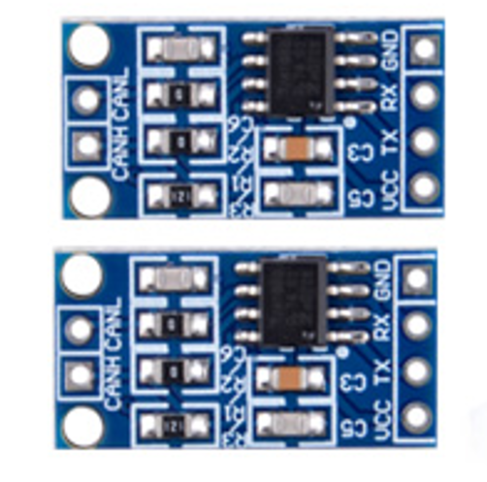

#### Pinout

* CANH: High-level CAN bus line.
* CANL: Low-level CAN bus line.
* VCC: Supply voltage.
* TX: transmit data input; reads in data from the CAN controller to the bus line drivers.
* RX: receive data output; reads out data from the bus lines to the CAN controller.
* GND: ground.

### Rain Drop Sensor

Raindrop Sensor is a tool used for sensing rain. It consists of two modules, a rain board that detects the rain and a control module, which compares the analog value, and converts it to a digital value. The raindrop sensors can be used in the automobile sector to control the windshield wipers automatically, in the agriculture sector to sense rain and it is also used in home automation systems.

Raindrop sensor is basically a board on which nickel is coated in the form of lines. It works on the principal of resistance. When there is no rain drop on board. Resistance is high so we get high voltage according to V=IR. When rain drop present it reduces the resistance because water is conductor of electricity and presence of water connects nickel lines in parallel so reduced resistance and reduced voltage drop across it. The more intense the rainfall the lower the resistance.

The rain sensor module/board is shown below. Basically, this board includes nickel coated lines and it works on the resistance principle. This [sensor module](https://www.elprocus.com/pir-sensor-circuit-with-working/) permits to gauge moisture through analog output pins & it gives a digital output while moisture threshold surpasses.

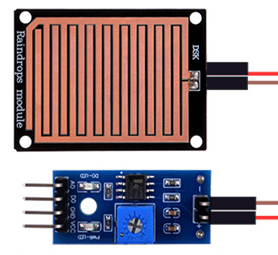

#### Pinout

* VCC -Connect to 3.3V/5V power supply.
* GND -Connect to Ground.
* AO -Analog output.
* DO -Digital output.

### Soil moisture sensor

The Resistive Soil Moisture Sensor Module consists of two probes which are used to measure the volumetric content of water. The two probes allow the current to pass through and then it gets the resistance value to measure the moisture value. However, the major issue with resistive soil moisture sensor is the corrosion of the sensor probes. It is because it is in contact with the soil while there is also a DC current flowing which causes electrolysis of the sensors.

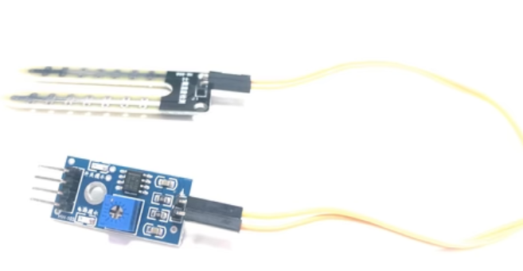

This sensor mainly utilizes capacitance to gauge the water content of the soil (dielectric permittivity). The working of this sensor can be done by inserting this sensor into the earth and the status of the water content in the soil can be reported in the form of a percent. This sensor makes it perfect to execute experiments within science courses like environmental science, agricultural science, biology, soil science, botany, and horticulture.

The sensor includes a fork-shaped probe with two exposed conductors that is inserted into the soil or wherever the moisture content is to be measured.

As previously stated, it acts as a variable resistor, with resistance varying according to soil moisture.

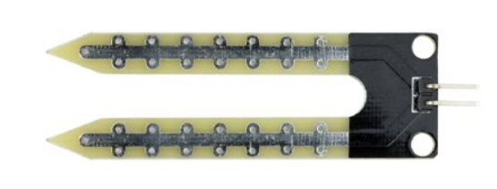

In addition, the sensor includes an electronic module that connects the probe to the Arduino.

The module generates an output voltage based on the resistance of the probe, which is available at an Analog Output (AO) pin.

The same signal is fed to an LM393 High Precision Comparator, which digitizes it and makes it available at a Digital Output (DO) pin.

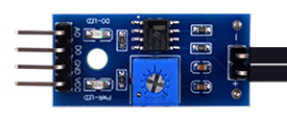

#### Pinout

* VCC -Connect to 3.3V/5V power supply.
* GND -Connect to Ground.
* AO -Analog output.
* DO -Digital output.

## C. Flashing the Arduino UNO R4 WIFI LED Matrix

Step 1: Use the USB-C Programing Cable connecting the PC and the Arduino UNO R4 WIFI.

Step 2: open the Arduino IDE, you should set a new sketch and clear all the codes.

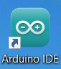

Set a new sketch:

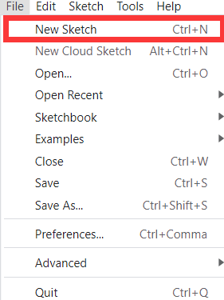

Then copy and paste the code.

**#include "Arduino_LED_Matrix.h"   // Include the LED_Matrix library**

**#include "frames.h"               // Include a header file containing frame data**

**ArduinoLEDMatrix matrix;          // Create an instance of the ArduinoLEDMatrix class**

**void setup() {**

**Serial.begin(115200);           // Initialize serial communication at a baud rate of 115200**

**matrix.begin();                 // Initialize the LED matrix**

**}**

**void loop() {**

**// Load and display the "fullOn" frame on the LED matrix**

**matrix.loadFrame(fullOn);**

**delay(500);**

**// Load and display the "fulloff" frame on the LED matrix**

**matrix.loadFrame(fulloff);**

**delay(500);**

**// Print the current value of millis() to the serial monitor**

**Serial.println(millis());**

**}**

Then click this to add the frames.h file.

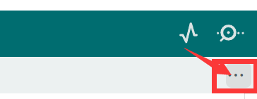

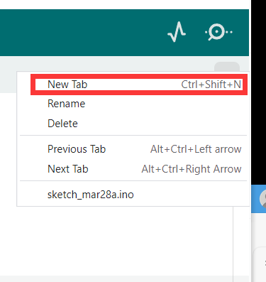

Then write down the frames.h and copy the code then fill in it.

**const uint32_t fullOn[] = { //turn on the LED matrix**

**0xffffffff,**

**0xffffffff,**

**0xffffffff**

**};**

**const uint32_t fulloff[] = { //off**

**0x00000000,**

**0x00000000,**

**0x00000000**

**};**

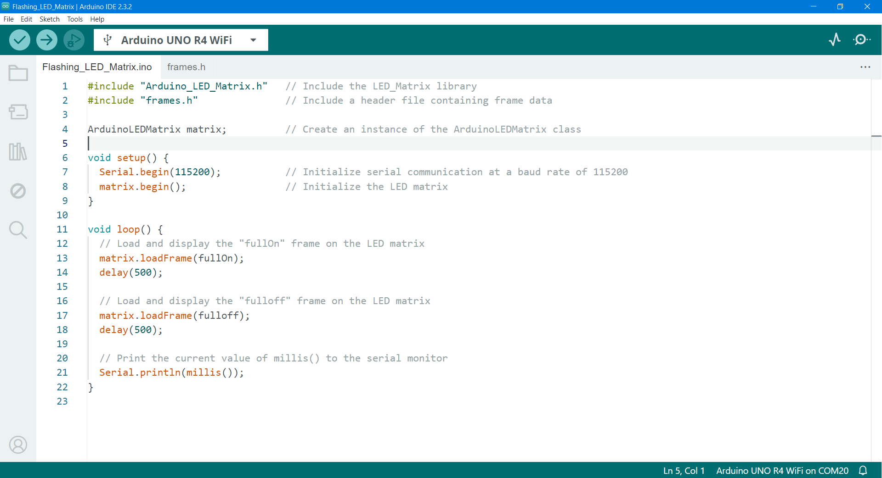

Step 2: select the com port where the Arduino UNO R4 WIFI is located in the software, click the upload button, you can upload the codes to the Arduino UNO R4 WIFI.

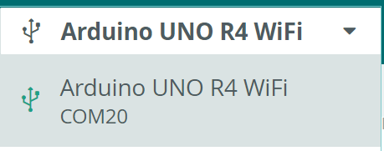



Lastly, you can see the Arduino UNO R4 WIFI Matrix flashing.

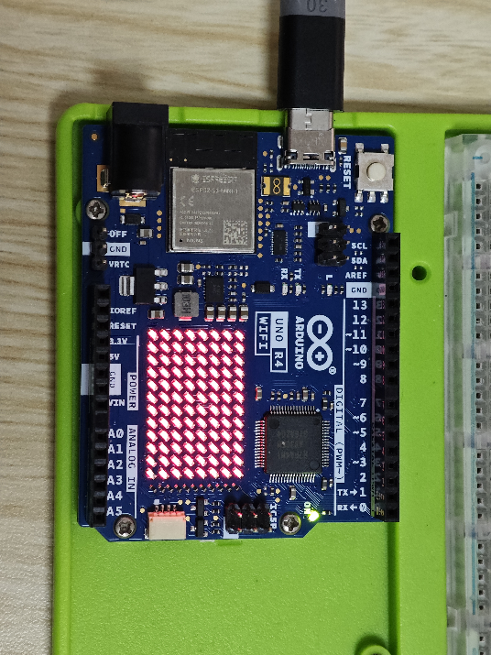

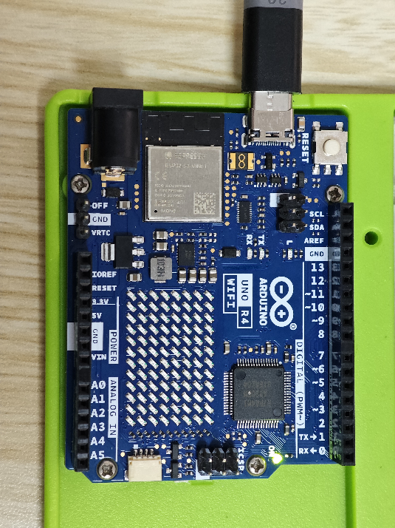

## D. Make an animation and play it on LED Matrix

In the official R4 WIFI new features, there is a section about LED matrix animation. Now let's upload and run the official animation, then make an animation and play it on LED Matrix. The Official have developed a tool that is used to generate frames and animations to be rendered on the LED Matrix in your browser. This tool is part of Arduino labs, and is therefore considered experimental software.

Step 1: Firstly, connect the Arduino UNO R4 WIFI with the PC. Open the Arduino IDE.

Step 2: Find and open the Examples for Arduino UNO R4 WIFI LED_Matrix PlayAnimation.

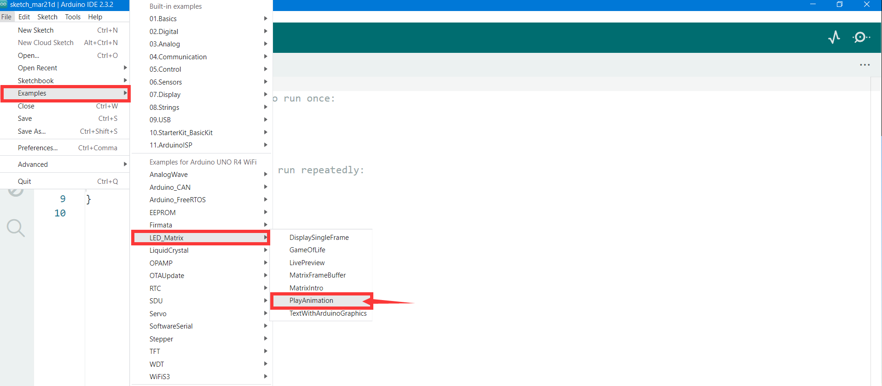

Then you can upload the code. You will see animation played in your Arduino UNO R4 WIFI.

Now let's start drawing our animation. If you want, make an animation by yourself. You can do this:

Click the hyperlink to go to the web page ([**ledmatrix-editor**](https://ledmatrix-editor.arduino.cc/)) or you can open your browser to ‘https://ledmatrix-editor.arduino.cc’.

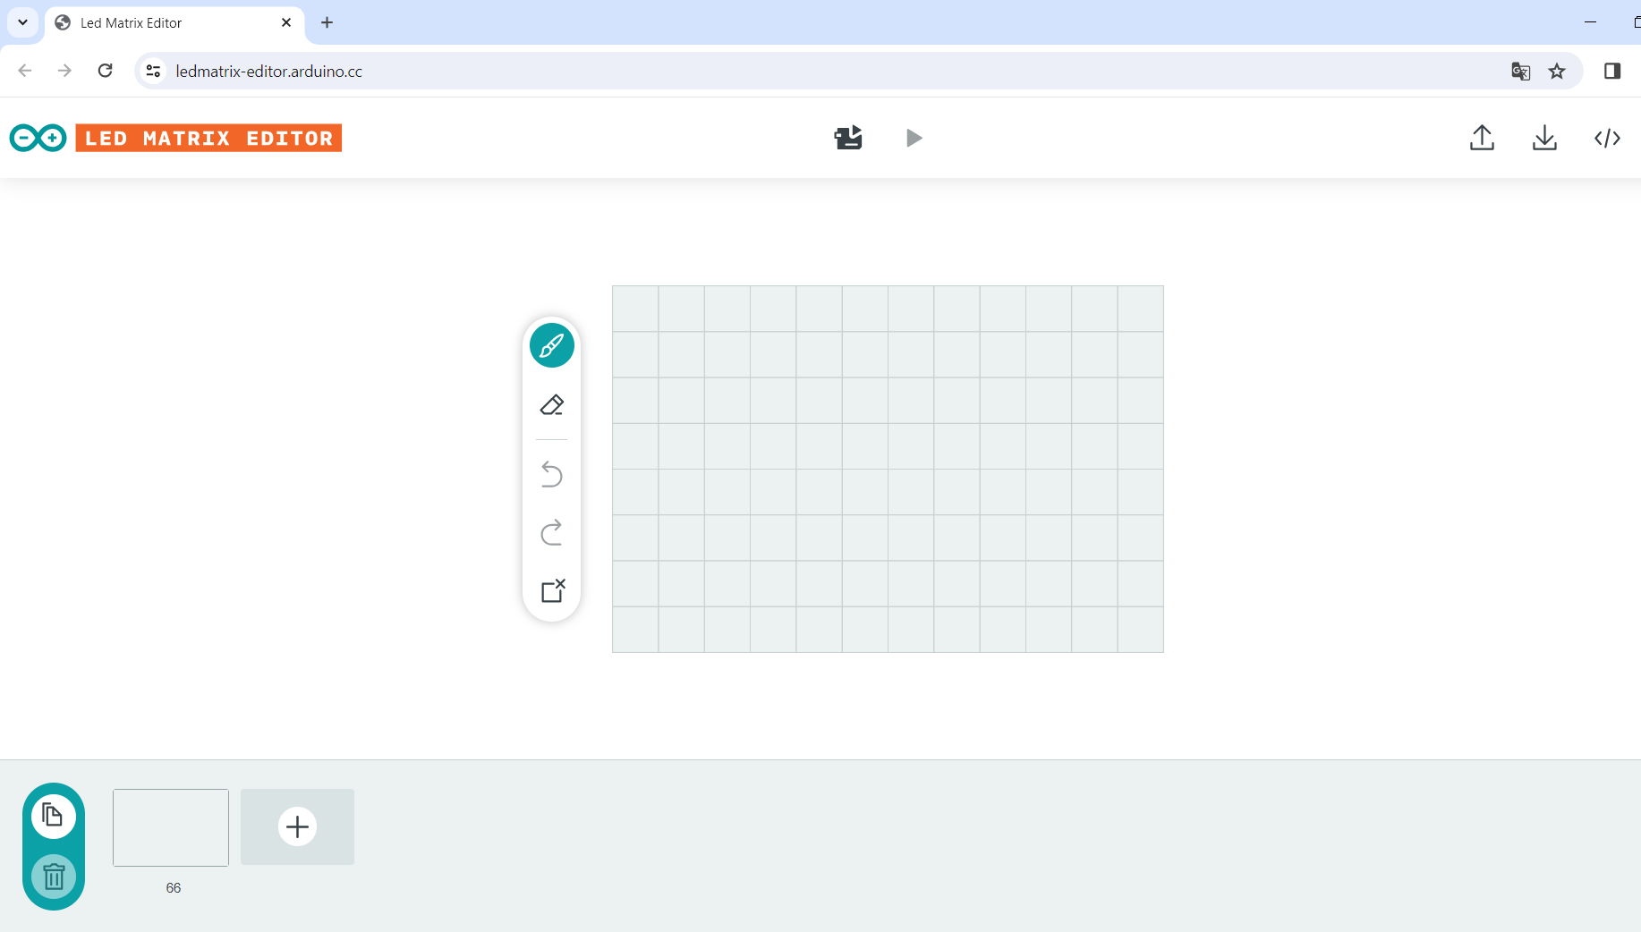

When you finished the animation, you can follow the steps to upload it to your Arduino UNO R4 WIFI.

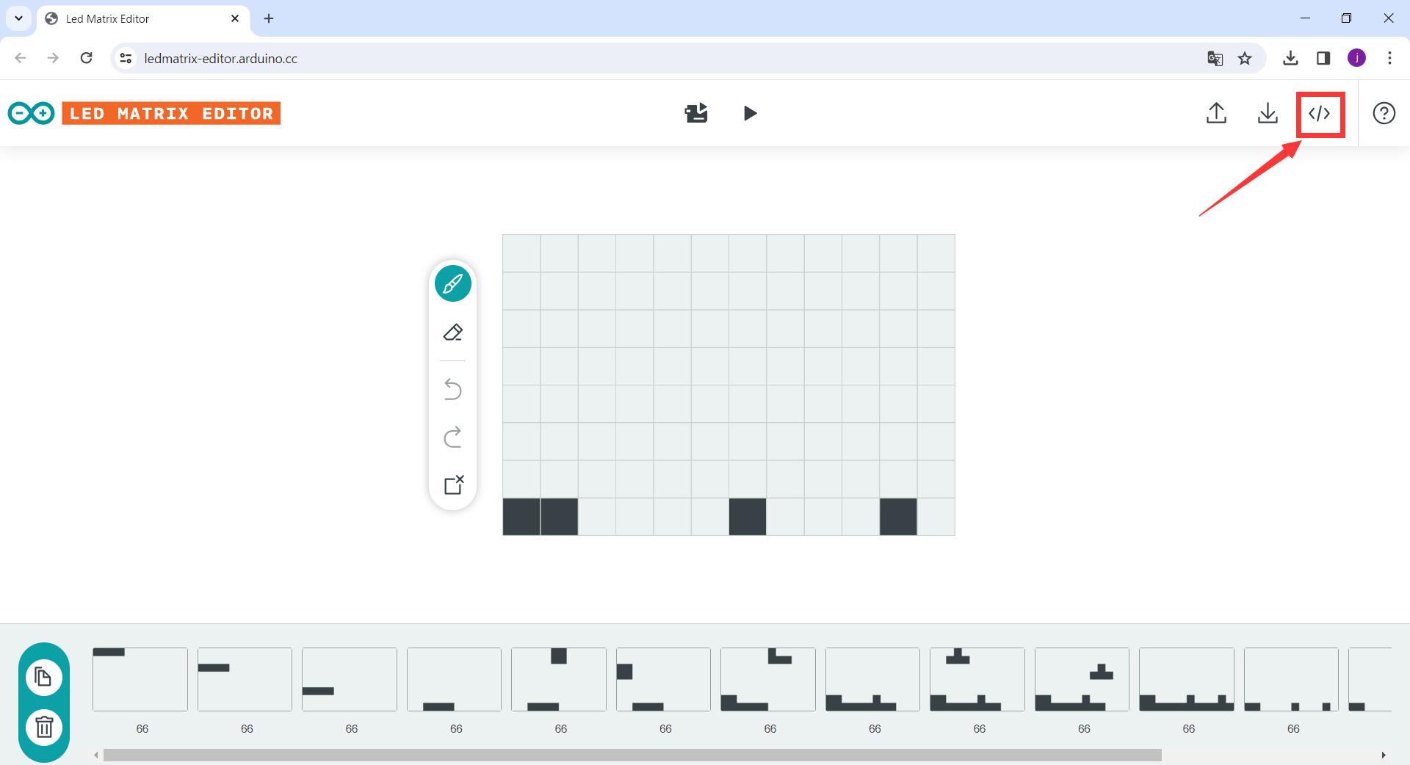

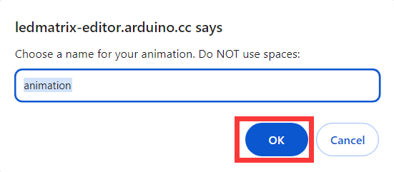

Then save the file to a location where you can find it.



Open this file just by notepad.



Then copy **all** codes to the Arduino IDE.

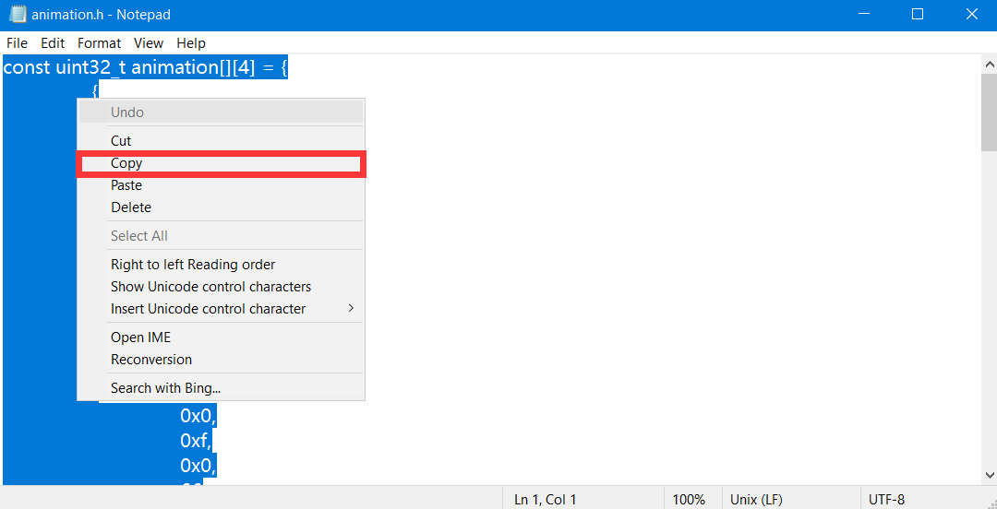

Click the animation.h **delete all**, and paste your own animation codes.



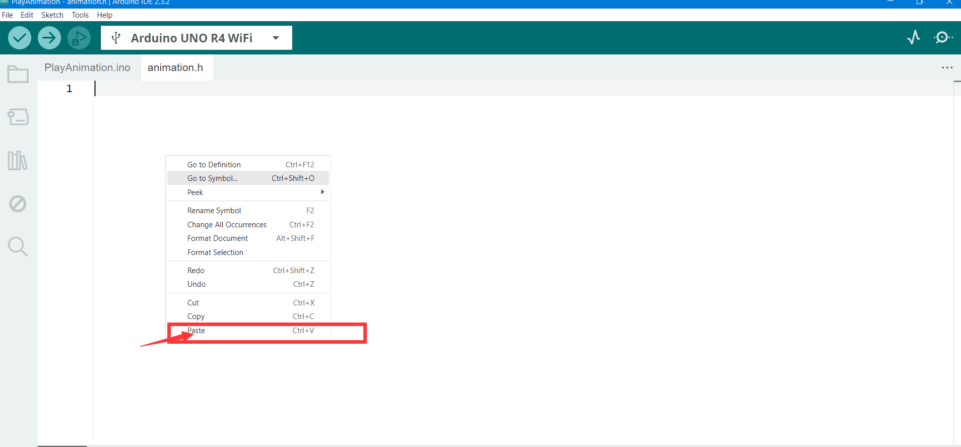

Finally, upload the code.

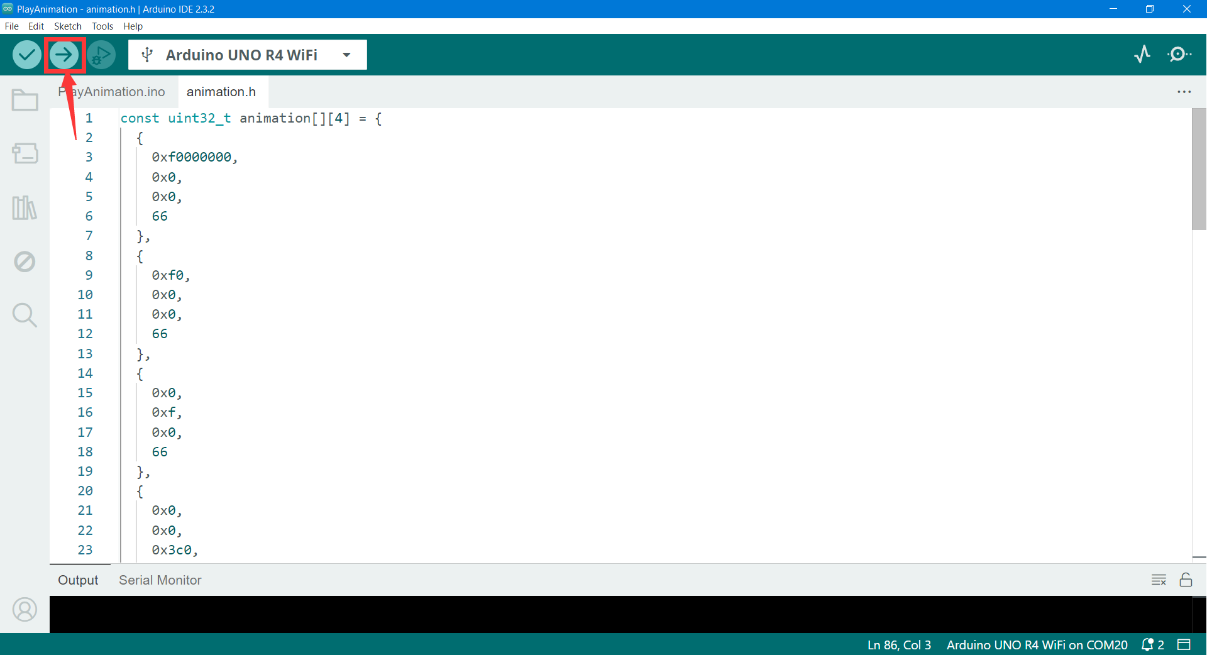

At last, you can see your animation you make just before, and played in the Arduino UNO R4 WIFI LED Matrix.

## E. Connect a LED with the Arduino and flashing it

Step 1: firstly, you need a LED and 1 x 220-ohm resistor, 2 x Male-Male Jumper wires, and the 52Pi Bread Board. Connect the Arduino with the LED like this:

Note: In the LED the long is the positive electrode.

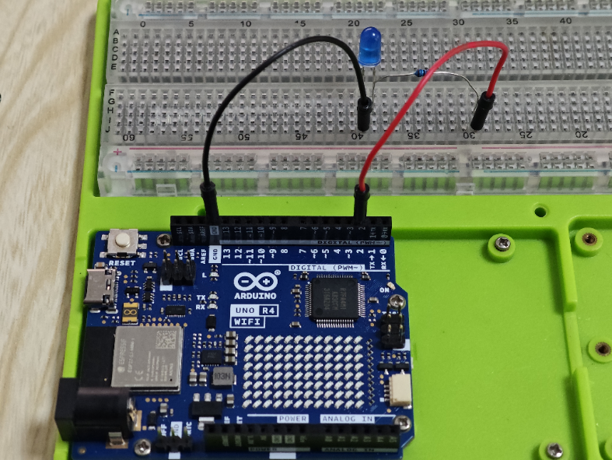

Step 2: open the Arduino IDE and copy and paste the code.

**const int LED_PIN = 2 ; //out pin**

**// the setup function runs once when you press reset or power the board.**

**void setup() {**

**// initialize digital pin 2 as an output.**

**pinMode(LED_PIN, OUTPUT);**

**Serial.begin(9600);**

**}**

**// the loop function runs over and over again forever**

**void loop() {**

**//flashing the LED**

**digitalWrite(LED_PIN, LOW); //turn on the LED**

**delay(500); //delay 500ms**

**digitalWrite(LED_PIN, HIGH); //turn off the LED**

**delay(500); //delay 500ms**

**}**

Select the com port where the Arduino UNO R4 WIFI is located in the software, click the upload button, you can upload the codes to the Arduino UNO R4 WIFI.





Flashing.

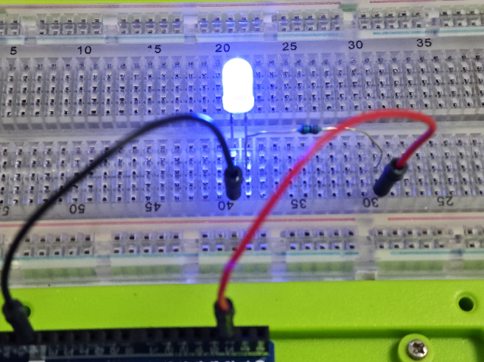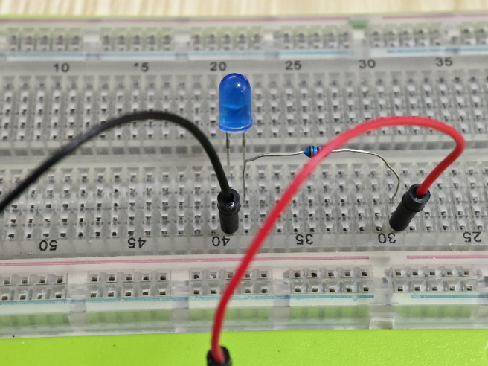

## F. Button control the LED

Step 1: firstly, you need a LED and 1 x 220-ohm resistor, 2 x Male-Male Jumper wires, 1 x press button and the 52Pi Bread Board. Connect the Arduino with the LED like this:

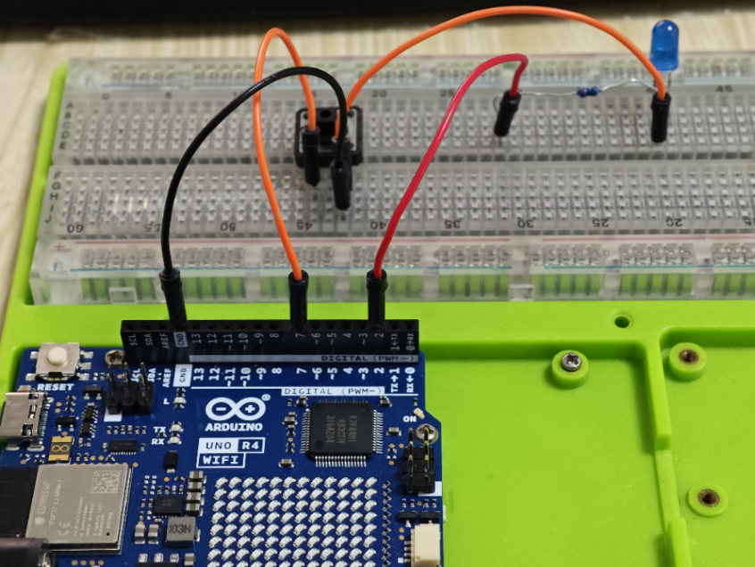

Step 2: open the Arduino IDE and copy and paste the code.

**// constants won't change. They're used here to set pin numbers:**

**const int BUTTON_PIN = 7;  // the number of the pushbutton pin**

**const int LED_PIN =  2;   // the number of the LED pin**

**// variables will change:**

**int buttonState = 0;   // variable for reading the pushbutton status**

**void setup() {**

**// initialize the LED pin as an output:**

**pinMode(LED_PIN, OUTPUT);**

**// initialize the pushbutton pin as an pull-up input:**

**// the pull-up input pin will be HIGH when the switch is open and LOW when the switch is closed.**

**pinMode(BUTTON_PIN, INPUT_PULLUP);**

**}**

**void loop() {**

**// read the state of the pushbutton value:**

**buttonState = digitalRead(BUTTON_PIN);**

**// control LED according to the state of button**

**if(buttonState == LOW)         // If button is pressing**

**digitalWrite(LED_PIN, HIGH); // turn on LED**

**else                           // otherwise, button is not pressing**

**digitalWrite(LED_PIN, LOW);  // turn off LED**

**}**

And upload the code by Arduino IDE. Then when you press the button you will see the LED turn on. When you free it, then it turns off.

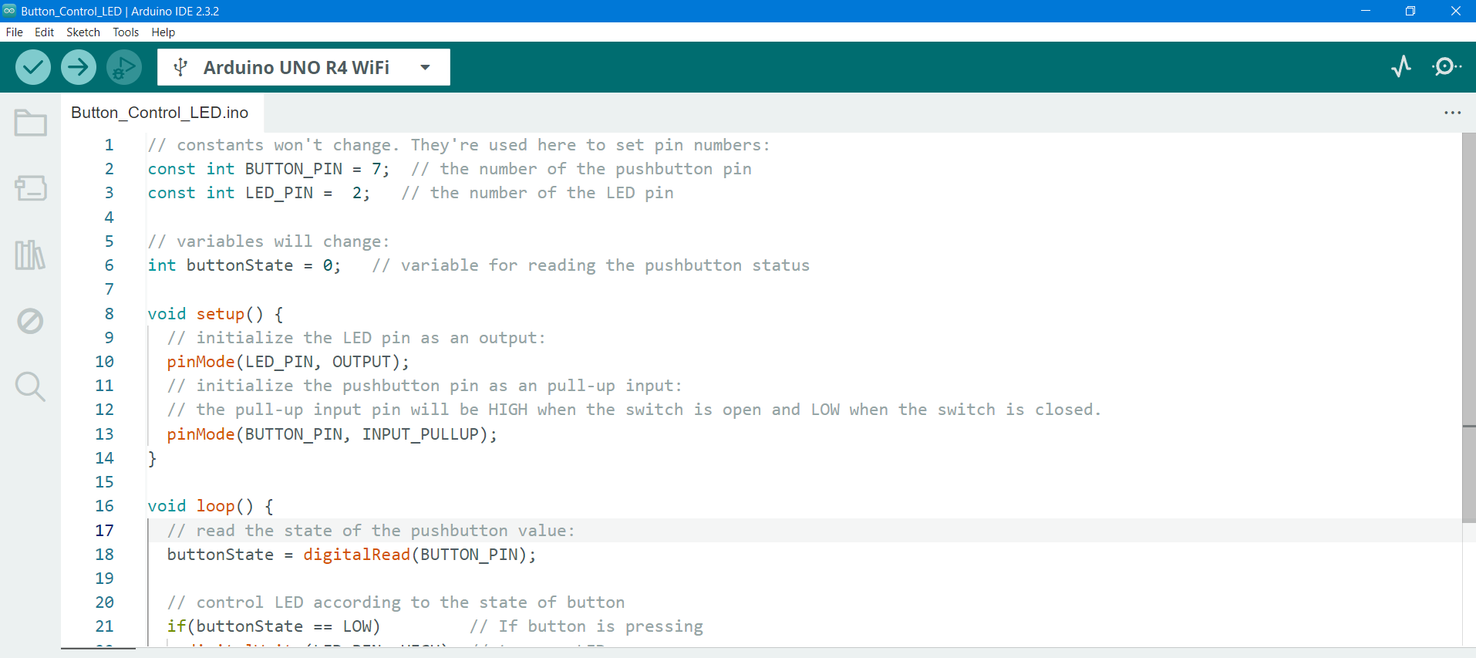

Then when you press the button the LED turns on.

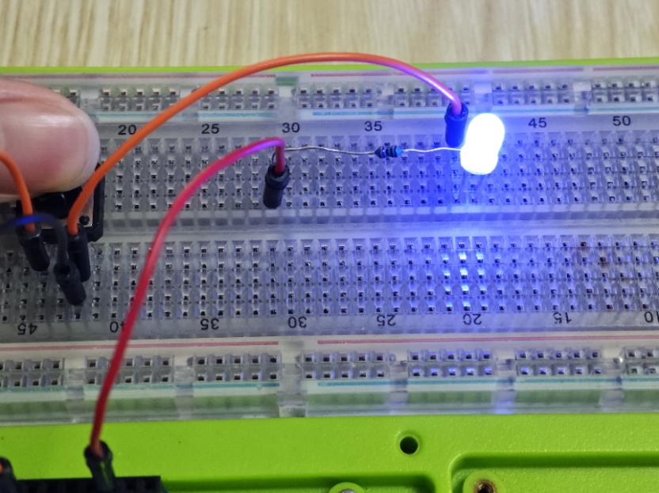

OK, you have already learned a lot of knowledge about the components in this kit, let’s get into next chapter and learn more funny projects!